Week 1 – Economics and markets

Introduction
- Importance of supply and demand in determining prices
- Parsimony of the mode is the aspect of reality the model retains. Model needs to be understandable and tractable, and the model can only be used within its “scope conditions”
  - Find the right metaphors, apply the right degree of abstraction, apply them to the appropriate questions, without overstepping their scope and or losing sight of the assumptions made along the way
- Key assumption 1: rational self-interest, homo economicus. Key assumption 2: equilibrium
- Positive v normative economics

Markets
- Institutions which facilitate exchange of goods and services between the demand and supply side. Price is simply the rate of exchange between money and a unit of the good.

Function of prices
- Signalling function – price is a signal of relative scarcity
- Incentive – higher prices incentivise producers to increase output, and incentivise consumers to substitute the good

Supply, demand, equilibrium
- Demand is group of agents willing and able to pay
  - Downward sloping due to the income and substitution effect
  - Effected by substitutes, complements, tastes, constraints
- Supply is group of exchanges producing the good and willing to exchange it for money
  - Upward sloping due to increasing marginal costs and profit incentive
  - Elasticity determined by, current capacity utilisation, time horizon, lead times
    - Shifts caused by technology, input factor prices, government policy
Market is any institution which puts these sides into contact
- Equilibrium price is the one which equalises supply with demand i.e. market clearing. Higher prices lead to gluts, lower prices lead to shortages
- Disequilibrium occurs because of frictions.
  - Menu costs to firms of changing prices and consumer behaviour considerations
  - Contractual obligations
  - Markets might not be transparent
  - Price controls can lead to excess demand or supply

Week 2

Producers are profit maximisers
- Consumers as utility optimisers and producers as profit maximisers: they have a specific, self-interested objective which they pursue rationally, meaning they make optimal decisions to maximise their objective.

Profit maximisation
- Input variable x (quantity produced) and output variable y (profit). Quantity is our choice variable or independent variable, and profit is our objective or dependant variable, as it flows from the production decision.
- We express profits as a function of output, and use calculus to obtain the profit maximising output. Differentiate profit with respect to quantity, and set y to 0.
  - Obtain a function for revenue (p x q)
  - Differentiate revenue function with respect to quantity to find marginal revenue
- When the increase in the top rectangle (via a higher price) equals the decrease in the side rectangle (via reduced quantity);
  - Q x – dP = dQ x P
  - dP/dQ = - P/Q
  - We know the slope of the demand curve is – ½ (this is dP/dQ)
  - We know P
- So -½ = - (10 - ½Q) / Q
  - Q* = 10
Can also do this directly using the profit question:
- Profit is maximised where marginal profits equal 0, or marginal revenue = marginal costs
  - dR/dQ = dC/dQ
  - Same as MC = MR

Summary
- Rational self-interest makes our model tractable. Consumers assumed to maximise utility; producers assumed to maximise profits.
- We use calculus to optimise the producer’s objective. Profit is maximised when marginal revenue equals marginal cost.
  - Revenue is maximised when MR = 0

Consumers as utility optimisers

Introduction
Preference relations between different consumption bundles:
- Strictly preferred: A is always preferred over B as it gives greater utility.
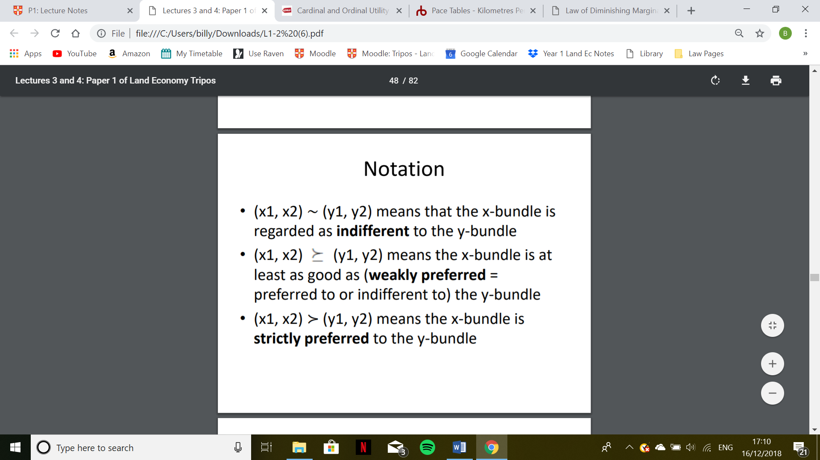
- Notation: (x₁, x₂) (y₁, y₂)
- Weakly preferred: A is as at least as preferred as B
- Notation: (x₁, x₂) (y₁, y₂)
- Indifferent: A is exactly as preferred as B, the consumer is indifferent between the bundles
- Notation: (x₁, x₂) ∼ (y_{1,} y₂)
- These can be represented graphically through dominated regions, preferred regions and other regions.

Indifference curves (Chapter 3)
- Indifference curves show all consumption bundles which give the consumer a given level of utility. Each point of the diagram is a consumption bundle, and the IC divides this region into the dominated region (worse bundles) and the preferred region (better bundles).
- Axioms of well-behaved indifference curve include complete, reflexive and transitive
  - Completeness: bundles are comparable, and consumers can make rational choices between products. May not be true considering game theory and clever marketing
  - Reflexivity: any bundle is as good as itself, consumers value identical goods identically
  - Transitivity: if you prefer x to y and y to z, you must prefer x to z. This is why indifference curves cannot intersect
- Other assumptions of well-behaved indifference curves
  - Monotonicity: more is better which is why ICs have a negative gradient. This is also why ICs further from the origin represent higher utility
  - Convexity of preferences: averages are preferred to extremes because of diminishing marginal utility.
  - Preferences are exogenous (given by nature) and stable (they’re actually malleable)
- Marginal rate of substitution (MRS) is the gradient of the IC. This is negative because of monotonicity and changes along the IC due to convexity (diminishing marginal utility)
  - Measures the rate at which the consumer is just willing to substitute one good for another
  - 𝑀𝑅𝑆 = ∆𝑥2 / ∆𝑥1
  - Total utility remains constant along the IC therefore
  - ∆𝑈 = 0 = 𝑀𝑈₁∆𝑥₁ + 𝑀𝑈₂∆𝑥₂
- We apply the principle of ordinal utility, meaning that consumers have a ranking of preferred consumption bundles, which shows us their revealed preference. We do not apply the principle of cardinal utility, the idea that we can assign bundles specific utility values, of which the magnitudes have significance.
Question for Schneider: if diminishing marginal utility is the purpose for a convex IC, would we assume that a constant unitary increase in both goods would shift the IC to the right by an increasingly small margin?

Irregular indifference curves
- Perfect substitutes would have a negatively sloped linear IC, because there is a constant rate of trade-off between the two goods. Only amount consumed matters, not configuration
- Perfect compliments have L-shaped ICs because increased consumption of one good brings no increase in utility unless coupled with increased consumption of another good.
  - Must be consumed in fixed ratios
- Neutral goods have vertical ICs
- Bads have a positively sloped IC, because to consume more of the bad and maintain your utility level, you must be compensated with an increase in a normal good
- Satiation

Budget constraints
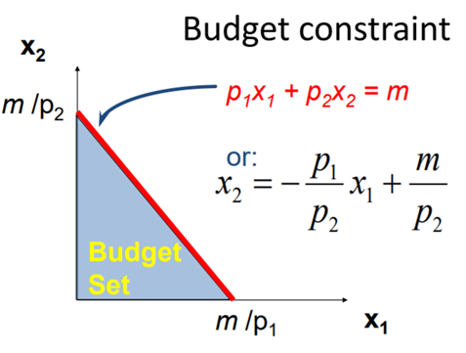
- Budget set is all the possible consumption bundles of x1 and x2 the consumer can afford, where x2 is often a composite good.
  - “X2=” achieved by dividing though by p2
  - Increasing X2 by 1 unit must reduce X1 by p1/p2.
  - This is the opportunity cost of consuming an additional unit of x2.
- Increase in income causes a parallel shift the budget constraint, to the right
- Decreasing the price of a commodity causes an outward pivot on the same axis, because the maximum (m/p1) increases as p1 falls.
  - No old choice is lost, and new affordable choices are added, so decreasing one price cannot make the consumer worse off if markets are independent.

Constrained optimisation
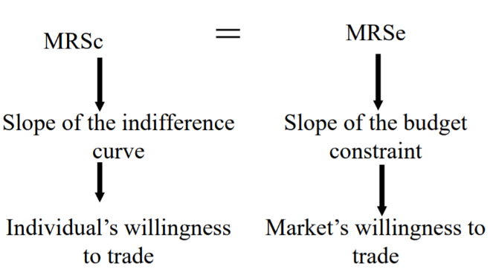
- Rational consumption is the point of tangency between the budget line and the IC furthest from the origin.
  - This is also the market clearing point, where individuals’ willingness to trade between the two goods equals the market’s willingness to trade between them.
- MRS_{c} = MRS_{e}, meaning that the indifference curve and budget constraint are tangent
  - MRS = p1/p2
- p₁X*₁ + p₂X*₂ = m, meaning that all income is spent

Caveat
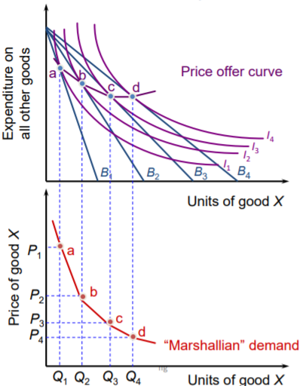
- These conditions may not be sufficient for consumption optimisation. Irregular ICs may give multiple points of tangency. Further, bundles may have satiation points within the budget set, meaning consuming at the budget constraint would be overconsumption.

Deriving the demand curve
- Deriving the demand curve: using incremental price decreases for p1, we pivot the budget line, showing us the quantity of x1 in our optimal consumption bundle for various p1s.
- This allows us to derive a Marshallian demand curve:
- As the price of X is continually reduced, the budget line shifts outwards, leading us to a consumption bundle on a new IC.
  - Different to the Engels Curve as we see price of good X on the Y axis, instead of consumer’s income
- Ordinary goods always have a downward sloping demand curve, meaning that decreasing the price of the good will lead to it being consumed in greater quantities at the new optimum consumption bundle

Hicksian Method – normal goods
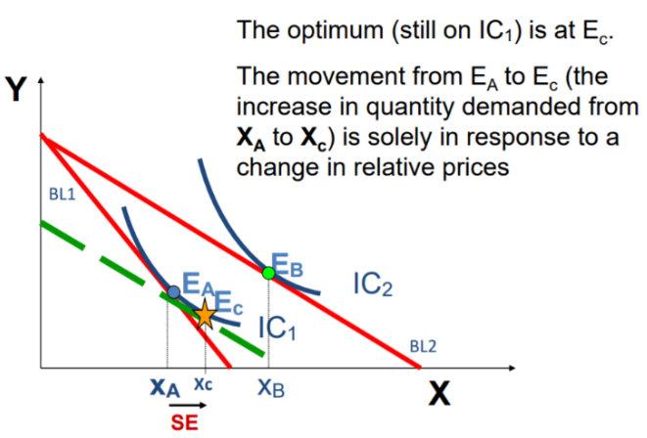
- We can use the Hicksian Method to view the relative significance of the substitution and income effects, as opposed to the Marshallian demand curve which captures the overall effect.
- Price of x1, p1, has fallen so we see a shift from BL1 to BL2, increasing consumption of x1 from XA to XB
- To isolate the substitution effect from the income effect we assess what the persons optimal consumption bundle would be if he faced the new price for X1 but no change in utility
- We do so by drawing a hypothetical budget line parallel to the new budget line BL2 and tangent to the original indifference curve
- This would give us an optimum consumption bundle XC, therefore the increase in quantity from XA to XC is the substitution effect: solely in response to changing relative prices, holding utility constant.

Comparative statics
- Show us how changing background factors displaces the demand curve
  - Changing the price of a substitute or complement will expand or contract demand
  - Shifting preferences in relation to the good will expand or contract demand
  - Increasing income will normally increase demand – Engels Curve
    - N.B. Quasilinear goods – no relationship between income and demand after a certain level
    - N.B.
- For inferior goods, bend the new IC at the higher income level to make it steeper than at the low-income level. This shows how increasing the budget constraint and lead to lower consumption of x1.

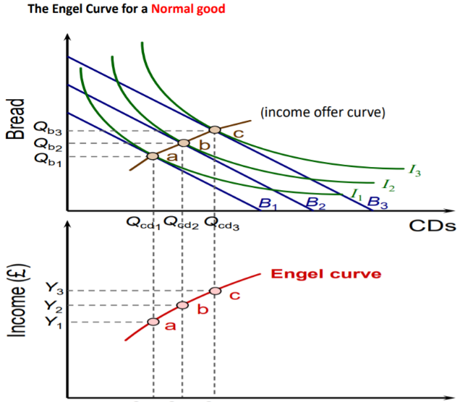
The Engels curve
- Shows us the relationship between income and quantity demand for a good, holding prices constant.
- Derived by joining up the optimal consumption bundles as income increases, i.e. the income expansion path.
- YED puts this relationship into proportional terms
YED = $\frac{\% change in quantity demanded}{\% change in income}$

Production theory

Isoquants
- Isoquants plot all the different combinations of two inputs which can go into the production process and result in the same level of output.
  - Whilst output is constant along the curve, cost can vary
  - Similar to IC but output can be quantified, utility cannot
- Isoquants are convex because we have diminishing returns to a fixed factor.
  - Only exceptions are where production inputs are perfect substitutes or must be consumed in fixed proportions, e.g. alloys.
- The marginal rate of technical substitution is the rate at which we have to substitute one input for the other to maintain a constant level of output. This means it is the slope of the isoquant at any given point.

Returns to scale
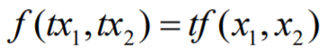
- Shows what happens when we increase the amount of all inputs equi-proportionally: does output increase by the same amount?
  - We assume so because of the replication argument, thus
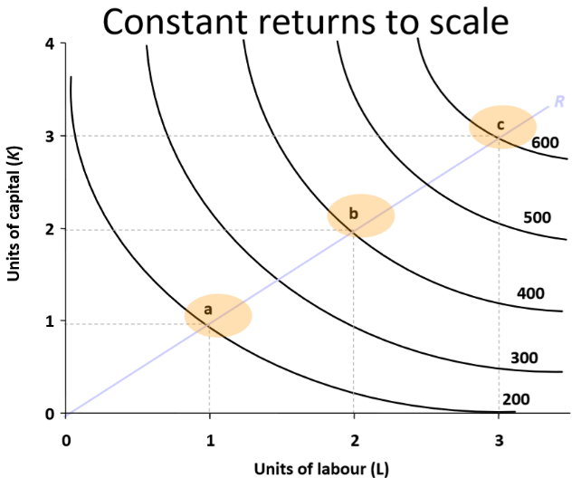
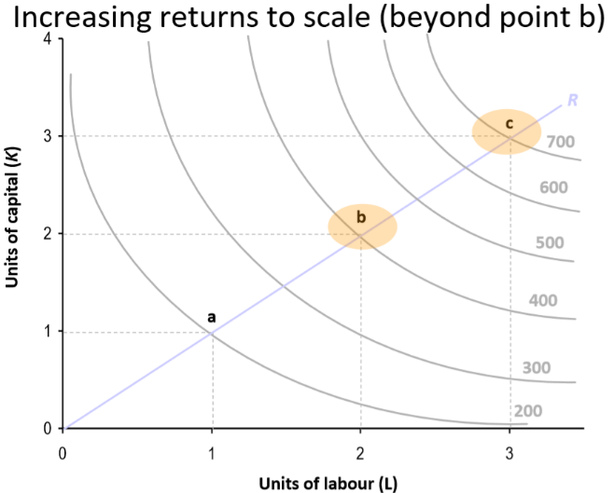

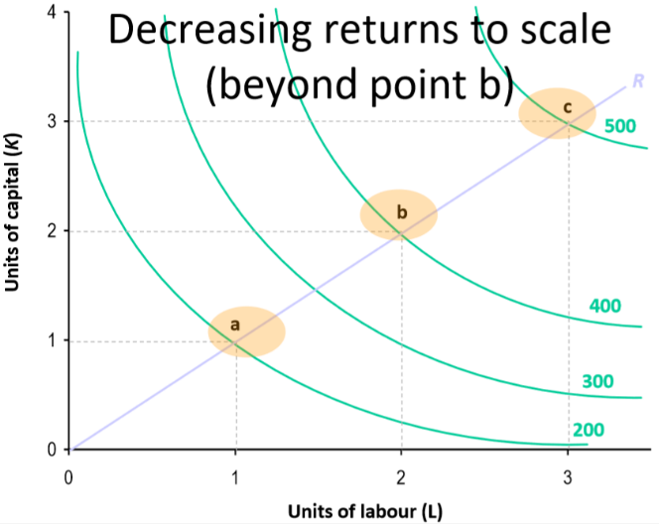
- Decreasing returns to scale are uncommon, particularly at low scales of production. If not, there would be a back-yard economy i.e. the existence of firms implies that bringing people together increases the returns to scale.
  - Decreasing returns only tend to set in for large multi-nationals.
  - Diminishing marginal product exists for one specific input whereas constant returns to scale exist when all inputs are increased.
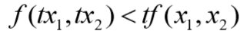

Cost minimisation – isocosts
- Isocost is the firm’s budget constraint, shows how the budget can be spread across the to different inputs.
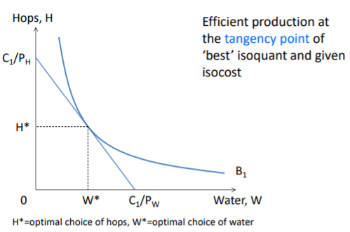
- Efficient production is at the point of tangency between the best isoquant and given isocost.

Technical Progress
- Technical change occurs because technology is not static. It shits the isoquant inwards, meaning we can produce the same level of output with less inputs.
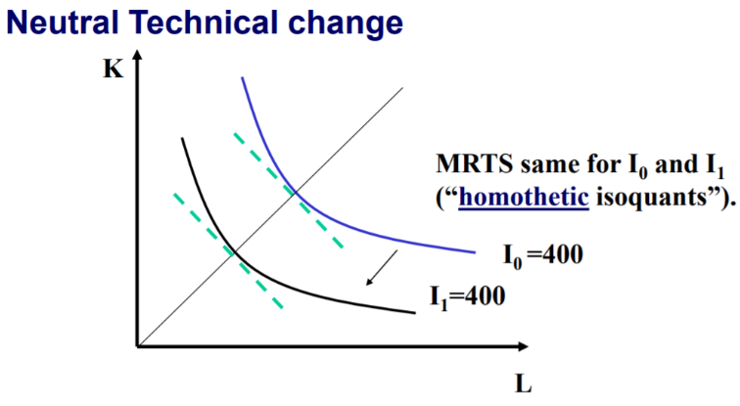
  - For example, improved education increases how effective we are at using inputs, thus shifting the isoquant inwards.
- Neutral, homothetic technical change is one which doesn’t change the ratio of inputs needed to produce an output, only the amount of each.

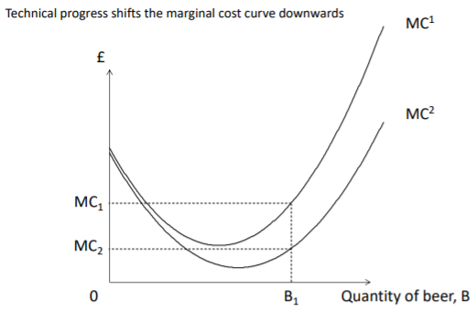
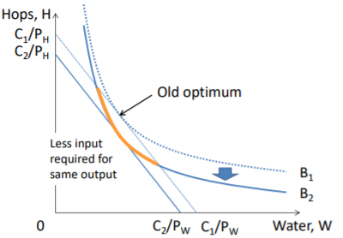
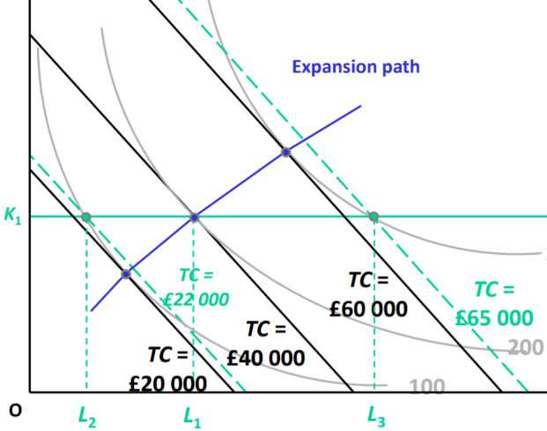

Expansion path
- This shows the cost-efficient input combinations for all conceivable output quantities

Varian chapter summaries
- Utility function represents preference ordering, but numerical values have no intrinsic meaning. Marginal rate of substitution, MRS, can be calculated form the utility function using MRS = – MU1/MU2
- Demand function depends on prices of all goods and income. For normal goods demand increases when income increases, but for inferior goods demand decreases when income increases. Ordinary goods see demand decrease when price increases, but Giffen goods see demand increase because the income effect outweighs substitution effect.
- Technological constraints of the firm shown by its production set (feasible combinations of inputs and outputs) and its production function (maximum output associated with a given amount of inputs). We can also show these constraints using isoquants, which show the different combinations of inputs capable of producing a given level of output. Isoquants assumed to be convex and monotonic, same as ICS. MRTS is the slope of isoquant, and is convex due to diminishing returns to a fixed factor (diminishing marginal product). In the long run factors are variable, and returns to scale shows us how output changes as we scale up all inputs by a fixed factor.
- Average costs are composed of average variable and fixed costs. AVC tend to increase with output, while AFC decrease. The net result is a U-shaped average cost curve. The MC curve is below AC when AC is falling, and above AC when AC is increasing. MC = AC where AC is minimised. The area under MC shows variable costs. Long run AC curve is the lower envelope of short run AC curves at different output levels.

Week 3 – Market Structure

Perfect competition and monopoly
- Differentiate between residual demand (firm) and market demand. Perfectly elastic demand gives perfectly horizontal residual demand curve. Marginal revenue equals price. Therefore firms produce where MR = MC, thus M = P.
Assumptions in perfect competition:
- Utility-maximising buyers and profit-maximising sellers. In reality, bounded rationality occurs
  - If buyers don’t react swiftly to price changes, the demand curve becomes more downward sloping. This might occur where firms seek to create market friction by closing product ecosystems to create vendor lock-in, increasing transaction costs (through switching and search costs).
  - Firms may not be able to achieve their goal of profit-maximisation where prices are sticky, or where it might be time-consuming or costly to adjust strategy.
- Homogeneous goods (fungible goods) assumed in perfect competition
  - Firms try to differentiate with branding or special features to move away from this
- Atomistic or thick markets assumed – need many firms, none of which is big enough to have market power over prices. This makes collusion more difficult, thus enables buyers to move to alternative suppliers if one raises its price.
- No barriers to entry or exit, especially important for long-run perfect competition and contestable markets.
Assumptions in monopoly:
- Sole supplier of a particular good or service, no close substitutes
- Higher barriers to entry into the market, allowing the monopolist to maintain long-run supernormal profits:
  - Economies of scale, leading to natural monopolies
  - Control over raw materials (vertical integration)
  - Patents, copyrights, licenses and other legal barriers
  - High sunk cost
- Firm is the market, SR and LR is the same because no entry into the industry is possible
- Monopolist faces a downward sloping market demand curve, and therefore has market power where it is able to influence the market price
  - Can set either quantity or price, but not both

Short run vs long run: perfect competition
- Some input factors more easily adjusted than others. This affects a firm’s expansion path (most cost-efficient input factor combination at different levels).
  - Low volume: labour intensive; high volume: capital intensive
  - In the short run we can only adjust labour, capital is fixed. Which factors are fixed and flexible depends on the firm and the time horizon.
- Short run costs curves are flatter than long run curves. This is because the long run cost curve requires initial capital investment required to increase output.
  - The curves become tangential at the point where the short-run amount of capital is just about cost efficient; past this point, we need inefficiently high amounts of labour, and cost is higher again in the short run. Here, we should increase capital
  - Supply expands over the long run and becomes more elastic, as firms can adapt their input mix more flexibly, producing cost-efficiently thus produce more at any price level.

Allocative efficiency
- Allocative efficiency in perfectly competitive markets means the equilibrium quantity maximises community surplus.
  - Producer surplus is their profit. Width quantity, height the difference between price and average cost at that quantity.
  - Consumer surplus is the difference between the demand curve (WTP) and price at the equilibrium quantity level, shown by a triangle
  - Community surplus sums these values
- We make assumptions to support the normative statement that maximising community surplus is actually desirable.
  - We assume that utilities between individuals are commensurable (saying one ‘util’ for one person is the same as one ‘util’ for another person) which is tricky because we don’t assign any meaning to the cardinal value of bundles, only the rank value.
  - We also assume budget constraints are given.

Perfect competition vs monopoly
- Equilibrium in perfect competition is allocatively efficient (P = MC) while monopoly results in a deadweight loss (P>MC)
  - In order to maximise profits, the monopolist doesn’t produce a range of output for which marginal benefits to the consumer exceed marginal costs to the firm. This is the deadweight welfare loss.
  - This deadweight welfare loss depends on the market power of the firm. This also determines their mark-up (difference between competitive price and monopoly price).

Productive efficiency

What determines the size and number of firms in a market?
- Initial decline of the long-run average cost curve is economies of scale, subsequent rise is diseconomies of scale. Minimum efficient scale i.e. output level at which a firm minimises its long run average cost, and therefore stops growing.
  - MES is what determines the long-run size of the firm, and the MES in relation to industry demand is what determines the number of firms.
  - Large MES relative to market demand leads to natural monopoly
MES can depend on:
- Production and logistics technology
- Decay of demand wrt distance from production i.e. catchment area

Strategy I – oligopoly & game theory introduction
Monopolists: quantity produced and price faced entirely determined by their own production tech and decisions, and the amount + nature of demand they face. Perfectly competitive firms: price and quantity entirely determined by market prices and their own production technology.
- Oligopolists must observe their competitors and react to what they do. We think about this strategizing using game theory.
  - Looking at simultaneous games, symmetric games are those for which the actions available and corresponding payoffs for players are identical, therefore they have the same dominant strategy.
    - Equilibrium is steady state; neither player has a unilateral incentive to deviate from their current action
    - Pareto-better outcomes are those which maximise community pay-offs e.g. silent, silent in Prisoner’s dilemma.
    - Confess, confess is pareto-dominated because there is a Pareto improvement to be had. Any game where individual rational self-interest leads to a Pareto-dominated outcome is called a social dilemma
- Where there is no equilibrium in dominant strategies, i.e. players don’t have a strategy that is universally better, we use Nash Equilibrium. This is a pair of mutual best responses
- Sequential games can be modelled using game trees. First mover assumes the second mover will make rational, optimising choice and then makes their own choice which maximises their pay-off based on this assumption.
  - Start at the terminal subgames, looking at the optimal choices for the follower, then go backwards to find the leader’s optimal choice. This is backward induction.
  - This rules out implausible Nash Equilibria to arrive at the Subgame-Perfect Nash Equilibrium

Varian chapter summaries
- Monopolist operates where MR = MC, charging a price that is a mark-up on marginal cost. The size of this mark-up depends on the elasticity of demand. This mark-up results in an inefficient amount of output, measured by the DWL, the net loss of community surplus. Whether an industry is competitive or monopolised depends on technology; if MES is large relative to market demand, the market will be monopolised. Technology can affect MES.
- A game shows the utility payoffs to each player for each configuration of strategic choices made. A dominant strategy gives a higher payoff regardless of what the other player chooses. Nash equilibrium is an outcome where each player’s choice is optimal, given the other player making an optimal choice. Prisoner’s dilemma shows an example where the Pareto efficient outcome is strategically dominated by an inefficient outcome. In a sequential game, pattern of choices can allow players to pre-commit to a line of play

Week 4

Non-collusive oligopoly
- Middle ground which leads to strategic interactions between firms, modelled using game theory which allows us to predict equilibrium price and quantity.
  - Two different types of games, one where producers decide what output to supply, and then accept prices, or one where producers decided what prices to charge, and then produce the corresponding output.
  - The firm’s strategic variable is debatable and can vary between markets, also depending on the firm’s assumptions about its competitors, and its ability to change the variable in question.

The Cournot Model
- Cournot oligopoly is a non-collusive oligopoly of simultaneous quantity setting, where each firm has to forecast the other’s output choice. We’re seeking an equilibrium in these forecasts, where each firm’s beliefs about the other are correct and therefore each firm is maximising its profits, on its best reaction curve.
  - Our profit expressed as a function of quantity: Profit = PQ1 – 5Q1
  - Profit = (10 – ½ Q)Q1 – 5Q1
  - Q is comprised of Q1 and Q2, our competitors output
  - Profit = (10 – ½ (Q1+Q2))Q1 – 5Q1
  - Simplify this function and differentiate with respect to Q1 to figure out how to maximise profit
  - D$π$1/dQ1 = 5 – Q1 – ½Q2
  - At the peak the slope is 0, so setting this to 0 and solving for Q1
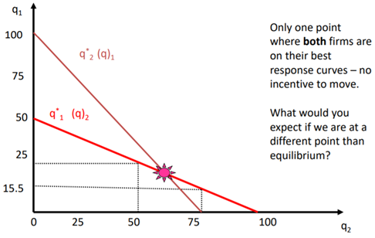
  - Q1 = 5 – ½Q

- Q1 = 5 – ½Q2 is our reaction function, and is also our competitor’s reaction function. When modelled graphically, the intersection of these two reaction functions is the Cournot-Nash Equilibrium.
  - Each firm assumes the other firm’s quantity choice is given, meaning they don’t consider bilateral deviations (Nash conjecture). This equilibrium is immune to unilateral deviations, and therefore is a Nash Equilibrium

The Stackelberg game
- Stackelberg game is a non-collusive oligopoly of sequential quantity-setting. This happens where one firm gains a first-mover advantage, and/or is the market leader.
  - For example, in the computer market, small firms used to follow the lead of firms such as IBM. Leader-follower relationships can also exists where there are strong brands or sentimentality, e.g. first café in a town.
- Sequential games solved using backwards induction: leader predicts what the follower will do (assumption it will set output where MR = MC), and then the leader set its own output in a way which maximises its own profits.

Follower’s problem
- If the leader is expecting the follower to choose an output that maximises its profits, it needs to understand the follower’s profit maximisation problem.
  - Inverse demand function P(Y) shows equilibrium price as a function of industry output, where Y = Y1 + Y2. Follower aims to maximise P(Y1 + Y2) – C2(Y2).

Bertrand’s hypothesis
- Bertrand competition is a non-collusive oligopoly in which players choose their price strategy, and let the market decide on the quantity.
- Simultaneous price-setting where firms have identical marginal costs will gravitate prices towards marginal costs
  - If firm 1 thinks firm 2 will set p2, and p2 is greater than firm 1`s MC, firm 1 will set p1 slightly below p2 to gain market share, sales and profits.
  - Firm 2 will do the same, and so prices should fall until:
P₁=P₂=MC

Collusion
- Horizontal collusion is “people of the same trade” (Smith) conspiring to raise prices. This is explicit collusion, but we can also see tacit collusion which achieves coordination without explicit arrangements.
- Price collusion is popular, but we can also have quantity fixing to keep prices above marginal cost (OPEC). Another arrangement is spatial partition where firms carve up markets and agree to grant each other geographical monopolies.
  - Opposite situation from Hotelling’s paradox

Determinants of market structure
- Viability of the above oligopolistic market structures depend on assumption of barrier to entry and homogeneity of the good traded. If these are relaxed, the resulting market structure may change.

Barriers to entry
- Exogenous barriers are given by the nature of the market itself.
  - Considerable set up costs such as large capital investments, capital intensity of production, training costs. Further examples include R&D and advertising costs. These sunk costs become even more problematic when the firm’s minimum efficient scale is very large i.e. there are large economies of scale.
  - Economies of scale can also come in the form of networking effectives, both with customers who trust larger firms and the ability to exert market power over suppliers.
  - Technology barriers to entry or learning effects
  - Limited number of licenses
- Endogenous barriers are those created by the incumbent firms within the market.
  - Control of a crucial resource, including through patented technology or control of a commodity. De Beers diamond monopoly in 1902 controlled 90% of global diamond mines.
  - Control over important infrastructure or distribution channels
  - Heavy investment in advertising and branding
  - Building excess production capacity
  - Limit pricing

Competition policy
- Less competition means more market power, higher prices, lower production, more deadweight loss and lower productive efficiency. So, policy-makers who are interested in consumer welfare and cost-efficiency should generally have the goal of fostering competition.
- Markets with few firms are less competitive, in the case of quantity competition because residual demand is not perfectly elastic and in the case of price competition because fewer firms are better able to coordinate a collusive price strategy.
- One way to achieve fewer firms is through M&A, the most comprehensive form of collusion (Stigler, 1964). A merger’s anti-competitive effects (increased market power) is called its coordinated effects.
  - When firms propose a merger, regulators will try to evaluate what the expected effect on prices and mark-ups in the affected market.
  - For that, they will look at the combined market share of the candidates, and at the price elasticity of demand (which is inversely related to firms’ market power)
- Regulators can also seek to lower barriers of entry.
  - Laws can limit vertical integration, such as requiring the operators of railway infrastructure (trainlines) to be separated from the infrastructure’s owners.
  - Most countries have competition law forbidding predatory pricing practices, but what about more subtle limit pricing?
  - Many countries also have whistle-blower leniency programmes; they lower the costs to firms of exiting these agreements, thereby increasing the inherent stability of cartels
- There are many issues with competition policy
  - Regulatory capture – difficulty to remain impartial, in the long run they can even begin to advise the firm
  - Also the issue of public vs private sector wage gap
  - Potential trade-offs between increasing competition, and incentivising innovation where R&D costs are high. Example of granting patents (temporary monopoly)

Varian chapter summaries
- Oligopoly contains a few firms who recognise their strategic interdependence, and there are a few ways oligopolies can behave depending on the exact nature of their interaction. In the quantity-leader duopoly model (Stackelberg), one firm chooses output and then the other firm follows. When the leader sets its output it considers how the follower will respond. In the Cournot model, firms set quantity simultaneously based on its belief about the other firm’s choice.

Dixit (1980) – role of investment in entry-deterrence
- Incumbent’s pre-entry decisions can influence prospective entrants view of what will happen if he enters – incumbent firm tries to exploit this possibility to its advantage
  - Classic view: Bain-Sylos postulate – incumbent maintains same output level after entry, then acquiring a Stackelberg leadership role. 2 opposing issues undermine this
    - Normally better to make an accommodating output reduction
    - Incumbent needs to create a credible threat of increasing output, hard given the entrant knowns the former fact
- Schelling (1960) suggests costly threats are made credible by advanced commitment which makes threat fulfilment optimal.
  - Spence (1977) applied this to entry via irrevocable investment decisions. Entrant would believe incumbent’s post-entry output would equal pre-entry capacity.
  - Bain-Sylos and Spence analyses extended by Dixit (1979) by considering when the incumbent will find it best to prevent or allow entry. Unclear about rules of the post-entry game and the resulting equilibrium
    - Nash equilibrium established either in quantities (Cournot) or prices (Bertrand)
    - Also possible entry will take over Stackelberg quantity-setting leadership
    - Although the rules of post-entry game are uncertain, incumbent can change initial conditions in its favour, i.e. investment alters its post entry MC curve.

Baumol (1982)
- Real markets are never perfectly contestable – it is a benchmark of wider applicability than perfect competition.
  - Characterised by optimal behaviour yet applies to a range of industry structures.
- Where there are economies of scale in the production of durable capital, intertemporal contestable monopolies will not perform ideally as time passes, even if they do so in the single period.
  - In the long run the least costly producer is vulnerable to entry by rivals whose appearance as it wastes valuable social resources

Characteristics of contestable market
- Contestable market is one into which entry is free and exist is costless. This is one attribute shared with perfect competition, but no others
  - Short-term requirement is no cost discrimination against entrants
  - Any firm can leave, recouping the costs incurred n the entry process. Where capital is saleable or reusable, any risk of is eliminated.
- Thus contestable markets are vulnerable to hit-and-run entry, even for transient abnormal profit opportunities.

Welfare attributes of contestable markets
- Normal profits only, due to their vulnerable to hit-and-run entry. Industry concentration doesn’t matter.
- Following from this argument, equilibriums in contestable markets are efficient (allocatively efficient, X-efficiency, productive efficiency
  - Any X-inefficiency is an incentive to enter, as its an opportunity for abnormal profit
- No product can be sold at a price below marginal cost. P < MC creates a profit opportunity for the entrant who drops the unprofitable marginal unit of output. Price being at least equal to marginal cost is important for regulation, because cross-subsidy is impossible, thus predatory pricing cannot be used as a weapon of unfair competition.
  - The argument applies symmetrically (P > MC is an irresistible incentive for entry) where a product is sold by two or more firms
  - Where there is a monopoly, P > MC isn’t a profit opportunity

How do contestable markets affect industry structure?
- Industry structure determined endogenously by contestability. Based on second welfare property of contestable equilibria – their incompatibility with any inefficiency.
  - Eq. incompatible with inefficiency in the organisation of an industry – if a two firm arrangement produces output at a lower cost than a 100-firm arrangement, the two firm arrangement is the long run equilibrium. If two-firm arrangement had the lowest cost for the given output vector of the industry, it’s a natural duopoly
- So, determine what structure is most efficient to produce the given output vector. Next, investigate when market pressures will lead industry structure to this eq.
  - First step is essentially computation – cost functions of a single firm, economies of scale – where average cost for a typical firm is U-shaped, can compare the output level to industry demand to calculate number of firms. Compare MES to demand.
  - Second stage of behavioural analysis - optimal structure depends on cost functions and output vector, which depends on the price charged by firms. Price charged depends on industry structure; this is a circular idea.

- Structure determined by efficiency requirement of contestable market. This requires minimisation of industry costs, thus market forces bring results consistent with normative analysis – so whatever structure shown to be least costly must emerge as the same structure selected by market behaviour. Hence industry structure determined endogenously, not exogenously.

Conclusion
- Policy implications: potential entrants exercise discipline over the incumbent, more so where entry is free. Only way to limit entry in this case is by behaving virtuously, offering customers benefits that competition would otherwise bring.

Week 5

Recap
- Cournot duopoly: quantity produced by the rival reduces our residual demand, so that quantities are strategic substitutes; one firm producing more incentivises the other firm to produce less in order to maintain prices. In the Cournot-Nash equilibrium, quantity exceeds monopoly equilibrium, but is less than perfect competition
- In the Stackelberg game, the leader uses its quantity as an instrument to manipulate the follow, so produces more than would be the best response in the simultaneous version of the game, forcing the follower to produce less. Overall quantity sits between Cournot and perfect competition, as does price and welfare loss.
- Bertrand hypothesis: if firms compete over prices and there are no market frictions, consumers are mobile and therefore there is a perfectly elastic residua demand curve. This leads to Nash Equilibrium where P = MC (Bertrand Paradox)
- Firms can circumvent this collapse of prices using collusion

Pricing strategies

Limit and predatory
- If exogenous barriers are not high, supernormal profits will attract entrants. Incumbents who are benefitting from economies of scale can price their product at a level that is below the minimum of the competitor’s AC curve. Limit pricing: limiting your price to your rival’s break-even point.
- If the rival has already entered the market, incumbents can employ predatory pricing, selling their product at a loss temporarily, which may force the entrant to exit the market if their cash reserves are lower than ours.
  - Developing a reputation as a predatory pricer could act as a deterrent to future potential entrants, becoming both preventative as well as reactionary measure
  - May not be sustainable if there are multiple potential entrants, who would sequentially enter the market – chain store paradox.
  - Investing in excessive production capacity is more credible as it shows credible commitment to deter; because prices are flexible they’re just cheap talk.
  - In reality aggressive pricing policies do occur because firms may not have information about each other’s costs, so low prices can bluff that we are more cost-efficient.

First degree price discrimination
- Perfect price discrimination entails selling each unit of output to the individual with the highest willingness to pay, thereby converting all of the consumer surplus into producer surplus. Note that this eliminates any deadweight loss, but undesirable for consumers
- Perfect price discrimination requires perfect information about each consumer’s tastes, preferences and habits
  - This is becoming more realistic due to the growth of e-commerce (ebay auctions), with features such as cookies, geolocators and targeted ads
- In general, firms need market power, heterogeneity of WTP amongst consumers, and a mechanism to prevent market seepage in order to price discriminate.
- Example could be consulting or law firms charging clients varying prices for the same service

Second degree price discrimination
- If the monopolist is unaware of each consumer’s WTP, it can construct an estimate of each consumer’s WTP using proxies.
- Non-linear pricing, also called bulk pricing, varies unit price with the amount you buy. Firms can offer different price-quantity packages to induce consumers to self-select, revealing their otherwise hidden WTP.
  - The pricing varies across units bought, as opposed to the person buying them (like in second and third-degree discrimination)
- One issue with this strategy is that bulk discounts encourage secondary resale markets; people could purchase the premium bundle and then resell the individual packs to the consumers with a low WTP.
  - Firms can counter this by trying to prohibit resale of individual items
- Another method of non-linear pricing is versioning, where firms offer multiple differentiated products, or varying quality, to extract maximum consumer surplus.
  - Consumers with a high WTP will purchase premium product with added features or comforts, vs someone with a low WTP who will choose the basic package
- Examples of secondary price discrimination include airlines (temporal pricing and versioning)

Bundling
- If a firm is selling two products, it is likely that consumers with different tastes will value different products in the portfolio differently e.g. two movies, one group of consumers values movie A at £10 and movie B at £6, and the other group vice versa
  - We don’t know each individual consumer’s WTP so cant perfectly discriminate
  - We know, however, that all consumers value both movies together at £16
  - So we can make them buy a bundle of both movies at £15.99, extracting more consumer rent by tweaking the price scheme
- Offer products only as a bundle is “pure bundling” and offering them both separately and as a bundle is called “mixed bundling”
- Potential pitfall: if we don’t know individuals’ WTP, why would we know the group’s?

Third degree price discrimination
- Third degree price discrimination, also called multi-market discrimination, is where a firm uses the characteristics of its consumers to vary prices, separating them into markets.
- This occurs when monopolist can segment its consumer market based on the price elasticity of demand of different groups, then varies it price across these segments. The monopolist will segment based on an observable characteristic which proxies consumers’ WTP, such as age or income
  - This requires the monopolist to have the power to prevent market seepage, where one group pretends to be the other, or reselling to the other.
  - This can be prevented using IDs to make a consumer prove they’re part of a segment
- This segmentation can occur geographically or demographically e.g. by age or sex
  - Student and pensioner discounts
  - Higher prices for consumers in cities
  - Peak and off-peak prices to separate those with jobs, therefore higher incomes
- The effect is that the consumer with a more price elastic demand, therefore lower WTP, faces a lower price than consumers with a high WTP
- Third degree price discrimination can be desirable where it makes an otherwise inaccessible good accessible to those with a low WTP, e.g. students and pensioners. Further, it can allow profit-making services to cross-subsidise loss-making but socially desirable services e.g. evening trains or countryside trains.
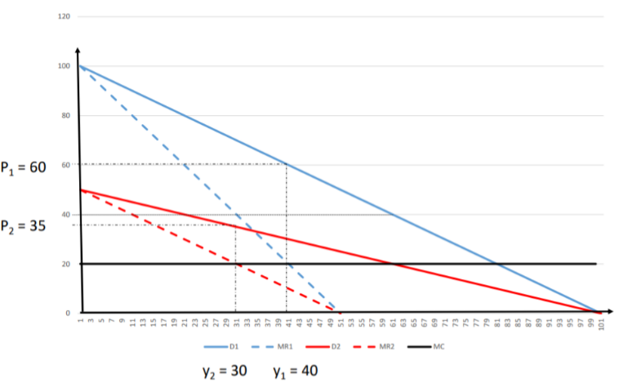

Evaluation of pricing strategies

Reality of pricing

Cost-based and value-based pricing
- Two pieces of information that firms use to make informed decisions about pricing: cost and market demand
- Most firms do not adjust prices very often, because production costs don’t change, because they are tied into long term contracts (B2B), and because of the menu costs associated with changing prices
  - These menu costs include jeopardising customer relations by reducing consumer confidence / certainty in prices.
- Many firms use cost-plus pricing, a rule of thumb whereby the firm calculates its break even price (average variable cost plus a certain mark up to recuperate fixed costs), and then adds a certain percent to this price to make a profit.
- Further, many firms use a reverse strategy where they price the product according to estimates for the reservation price of the marginal customer. This is value-based pricing as it uses an estimated market value of the product to price it

Theories of the firm
- So far used the neoclassical model of the firm as a rational profit-maximising entity.

Managerial model and principal-agent theory
- Crucial aspect of the modern corporation is the decoupling of ownership from management. The owner is the principle, and the CEO is the agent. The focus of this theory is that the two have a conflict of interest
  - Principle wants to maximise profit, but agent is paid a salary and has no incentive to maximise profits. Agent wishes to minimise their effort in doing their job.
- Importantly, the principle’s effort is not ‘contractable’ or controlled / measured.
  - Principle may have ways to increase monitoring, but these are imperfect
  - Asymmetric information between the principle and agent regarding the agent’s effort results in a moral hazard, and so the agent will exploit the information incompleteness that works in their favour.
  - Profit-sharing schemes can tie salary to profit-maximisation incentive
- Manager exploits asymmetry and profit satisfices before maximising their own utility, which depends on salary, job security, power and professional excellence

Other theories of the firm

Bureaucratic firm
- Max Weber argued no large organisation can exist without a bureaucracy, and that they key to efficiency is routine.
- A strictly bureaucratic firm achieves the optimum levels of speed, unambiguity, reduction of friction and material, unity and subordination. Where everybody knows their place and functions, and all processes are standardised and normalised into routine, the organisation will run more efficiently.

Behavioural approach
- In contrast to the bureaucratic approach, Herbert Simon emphasised the importance of psychology. Simon popularised bounded rationality as a counter-model to the rational agent, arguing that decision-makers use rules of thumb because they lack the information and computing power to decide optimally.
  - These heuristics lead to satisficing, whereby managers set a target, and once achieved they ‘settle’ and stop trying to increase it further.
  - Increasingly likely in large corporations where multiple stakeholders with different aims have decision making power. Firm satisfices between them all
- Agents are present-biased and prefer immediate gratification over delayed gratification. This can lead to persistent short-termism in a firm and an underinvestment into future opportunities, thus an absence of profit-maximisation.
- As well as rationality, our assumption of self-interest may also be violated due to reciprocal behaviour, whereby people are prone to repaying past favours and retaliating against past offensives. This leads to a culture of give and take, and a chain of gift exchange.
  - This means a key task of management is to foster a co-operative work environment
  - March and Simon (1958): organisation is the transformation of conflict into cooperation.
- Size and scope of the firm can be determined by rival’s performance and by the firm’s own performance relative to past targets. Further, as managers are slow to adjust targets to market changes, organisational slack can develop, whereby if the firm overachieves, targets remain the same and “slack” develops, which is taken up if the firm then underperforms.
- Consumers prefer price stability, so firms seeking to achieve this may have to forego short term profit maximisation

Transaction costs theory of the firm
- Provides another reason for the existence of firms; firms can organise production and distribution in a manner incurring lower transaction costs than the free market.
- Coase emphasised the “Problem of Social Cost”, the costs of contracting using the price mechanism, including search, bargaining, and enforcing costs.
- According to this theory, the size and scope of firms is determined by the cost of internalising a process in a firm, relative to the transaction costs saved as opposed to using the market.
  - After a certain point, as the firm branches beyond its core specialities, the cost of internalising a process through training or vertical integration rises with scale. Therefore, the firm exists at the size and scope at which transaction costs are equalised.

Week 6

Labour markets
- In the labour market, firms are the demand side and jobseekers are on the supply side.
- The labour supply curve is backward bending because of the diminishing marginal utility of consumption, made possible by earning, falls below the level sufficient to entice consumers to sacrifice their leisure time to work. Also, if wages fall, individuals on already low wages may be forced to work more hours to make ends meet, thereby increasing supply as prices fall.
- In the neoclassical model with firms as profit-maximising entities, and competitive markets for both inputs (employment) and outputs (products), the wage is equal to the marginal revenue product of labour.
- Demand for labour downward sloping as we assume a declining marginal product of labour, assuming a fixed amount of capital
- Comparative statics: background factors can shift the labour demand curve.
  - Price of the firm’s output
  - Marginal productivity of labour, which can be increased by technological progress, investment by the firm into human capital, or investment by individuals into their own human capital, increasing their skills to increasing their productivity

Signalling
- Spence argues university education does not actually increase productivity, it merely reduces asymmetric information by signalling your intrinsic productivity level to your prospective employer, so they offer you a higher wage.
- Signalling device works because the cost of education is only justified for the productive worker, as the tedium of studying is lower for them,
  - To be credible the signal needs to be costly, to stop everyone from gaining a university education in pursuit of a higher wage (no more information value in the signal).

Unemployment
- Neoclassical view of unemployment is that all unemployment is voluntary in the sense that unemployment only exists where the market wage is below someone’s reservation wage.

Minimum wages
- Acts as a price floor and can therefore lead to excess supply of labour on the market. This leads to involuntary unemployment through welfare losses
  - Additionally, in the long run firms may change their factor input mix, automating work to circumvent the increased labour costs
- However minimum wages can be effective in raising wages without decreasing employment where firms have local monopsony power over labour, and are therefore able to drive down prices below the market clearing level
  - An alternative remedy to monopsony power is to create trade unions which bargain with employers collectively, creating a bilateralised monopoly whereby both sides of the market are concentrated.

The online economy
- Structural change of national economies from manufacturing to service industries, and increasingly service which use digital technology and online platforms

Net neutrality
- Previously looked at natural monopolies, which can harm consumers by increasing prices above marginal costs to exclude some consumers from the service
- More subtle strategies include second-degree price discrimination, extracting rent by making a premium and basic version, with characteristics to direct consumers with a high WTP to purchase the premium version.
  - The basic version underserves customers, with the firm extracting all of the consumer surplus
  - Premium customers are served an allocatively efficient amount, receiving some surplus and information rent.
- ISPs can offer different speed at different prices, making a basic bandwidth intentionally slow to make high-value customers choose the faster package
  - Other practices include discrimination by protocol, by IP address and peering discrimination, which privileges certain websites
- Regulation efforts can include separating the operation of infrastructure from the operation of services, so the ISPs are viewed from the physical network
  - Other approaches include the creation of publicly funded infrastructure
  - The term “net neutrality” applies to any policy aiming to prevent the preferential treatment of some customers, websites or protocols.

Network externalities
- Network effect or demand side economies of scale refers to situations where a good becomes more attractive the more it is consumed, such as social media websites like YouTube.
- One positive welfare effect of this property is that the transaction a user makes with the social media company has external benefits beyond the buyer (user) and seller (social media company), namely to content creators. This is a positive externality.
- One issue with this property is that network effects mean the minimum efficient scale of such social media firms can be very large, meaning we face the danger of natural monopolies leading to DWL.

Pricing of online services
- How do social media firms create monopoly rents if they levy no monetary cost on the consumer? No such thing as a free lunch, firms make money through advertising.
- Most physical advertising is wasted, but because of information technology, online firms can offer targeted advertising or contextual advertising
  - Geotargeting: using location services to tailor advertising to your physical location
  - More sophisticated targeted advertising strategies use user profiling, trackers and cookies to gather as much user behaviour information as possible
- In essence, the currency in which you pay is information, not money. This raises the issue of property rights, i.e. who should own this information. Regardless, the “price” you pay in information is likely inflated because of the huge network effects

Information goods / zero marginal cost
- Goods that consist of information are not destroyed when consumed, and relatedly, consumption is non-rival
- Some goods are also non-excludable e.g. sharing sites which would rip CDs and share their music.
- Another aspect of information goods is that many of them are expensive to produce with huge sunk costs e.g. movies. High set-up costs that are mostly sunk are often a prerequisite to monopoly. The second aspect is low marginal costs. We also observe this in information goods, such as streaming services.
  - The factors have indeed led to monopoly, with Disney having a 34% in the US film market

The gig economy
- Another area of the economy which has made market entry easy through digital technology is the gig economy.
  - Prime example is Uber, a business model bringing together users and drivers. Client-driver matching process is automated, and so are payments.
- These markets are flexible, short-term contractor jobs instead of long-term employment relationships, and are organised by a platform.
  - This platform centralises interactions, and such platforms are increasingly used because digital technology has radically reduced transaction costs, including search, bargaining, contracting and enforcement costs.
- Further, digital technology can attenuate the asymmetric information problem inherent to many of these services by providing rating and review systems. This creates reputation incentives for both sides to provide a good service.

Issues with the gig economy
- A downside of gigs is that contractors do not enjoy much of the security that regular employees have, such as insurance, pensions and employment protection
- Further, the flip side of the flexibility enjoyed by contractors is the income and job insecurity the gigs bring, termed precarious work.
- Regulators will seek to keep multihoming costs, the costs to both buyers and sellers of switching to a different platform, down. This is because a platform like Uber creates both monopsonist power for buyers and monopoly power for sellers. By encouraging access to other similar apps, consumers can use whichever service is cheapest, and sellers can use whichever service provides the better working conditions.

Week 7

Need for government intervention

Promoting competition

Week 8

The Macroeconomy
- Different phenomena emerge such as inflation, exchange rates, unemployment rates etc. Macro environment affects the firm’s market conditions.
- National output can be measured in 3 ways:
  - Output: sum of value added in each sector
  - Income: sum of payments to factors of production
  - Expenditure: sum of expenditures on final goods and services
    - Nominal values should be converted to real values
    - Measures of income may ignore goods not traded on markets – the ‘care’ economy of housewives, the ‘hidden’ or ‘shadow’ economy
    - Doesn’t distinguish between ‘goods’ and ‘bads’. Broken windows parable
    - Market value may not be true value e.g. because of free rider problems
    - Effects of inflation countered by increasing product quality
- Alternative measures include
  - HDI – weighted average of various factors
  - Happiness index – both subjective and objective indicators of individual well-being
- Circular flow: households own and supply FoPs to firms, receiving income in return. Firms use FoPs supplied by households to produce goods and services which they sell to households.
  - Inner loop shows the flow of resources
  - Outer loop shows the flow of money
  - Savings and investment represent injections and leakages. Role of banks is to help equalise the two so there are no net leakages, in equilibrium the two are identical
  - Leakages include net savings, net taxes and import expenditure
    - Two kinds of taxes are direct taxes levied on incomes and indirect taxes levied on expenditures. These are included in GDP, so we need to measure GDP at basic prices
  - Injections include investment, government expenditure and export expenditure
    - Government expenditure on goods and services increases GDP
    - Transfer payments do not increase GDP

Components of National Income
- In a closed economy Y = C + I + G -Te
  - Income = consumption + investment + government expenditure – indirect taxes
  - Household’s personal disposable income at basic prices = Y + B – Td
    - Income + transfer payments – direct taxes
  - Savings = (Y + B -Td) – C
    - Difference between disposable income and consumption
- In an open economy we have to consider imports (Z) and exports (X), giving next exports
  - Y = C + I + G + NX – Te
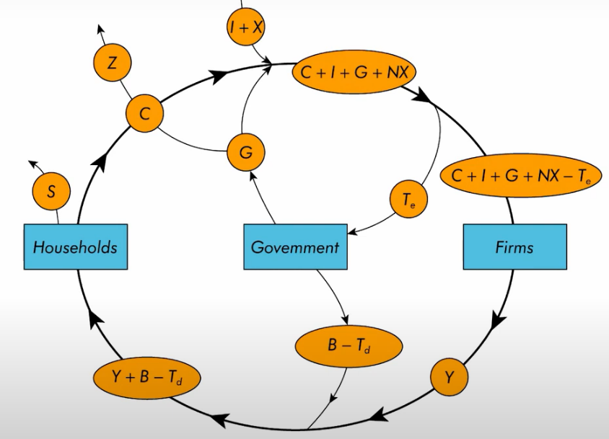
  - Government injects benefits – taxes to households and injects government expenditure into firms (by buying goods). Government extracts taxes from expenditure
  - Savings leave the economy and re-enter through investments or through exports
- Potentials for disequilibrium stem from government budget surpluses or deficits, and balance of payments surplus or deficit.
  - Can rearrange to find NX = S – I, meaning the trade balance is equal to the net capital flow. A country with a trade deficit is a net borrower (S<I).
- Consumption is the largest component of AD (2/3). It is the value of all goods and services bought by households
  - Can distinguish between durable and non-durable goods. For durable goods, we don’t want to include the value of resales, durable goods are also susceptible to depreciation
  - Keynesian consumption function: C = C(Y – T)
  - MPC is the marginal propensity to consume; how much does an increase in disposable income increase consumption.
  - MPC is the slope of the consumption function, which has an intercept that is the subsistence level
  - 0 < MPC <1, average propensity to consume falls as income rises (APC = C/Y), and income is the main determinant of consumption.
  - As income rises, consumers save a bigger faction of their income so APC falls.
  - Income distribution will affect total consumption; economies may suffer from ‘underconsumption’ as they grow, which is problematic where consumption is driving growth.
  - However as incomes grew APC did not fall, Kuznets showed that C/Y was stable from decade to decade i.e. the relationship between growth in C and Y was 1-1.
- Proposed explanations included Irving Fisher intertemporal choice; consumers are forward-looking and chooses consumption for the present and future to maximise lifetime satisfaction. Consumer choices are subject to an intertemporal budget constraint
  - Consumers engage in consumption smoothing
  - The timing of income is irrelevant because the consumer can borrow or lend between periods
- Modigliana life-cycle hypothesis; incomes varies over the phases of the consumer’s life cycle and borrowing and saving allows consumers to achieve smooth consumption over time.
  - Therefore, households in their ‘prime’ may not consume a lot, but pensioners households may consumer more (C is high as a proportion of Y).
  - APC is high when we’re young and old, and APC is low in the middle
- Normal income theories (Friedman). Income disaggregated into two sources: permanent income and transient income (lottery win, temporary job loss, tax rebate). Consumers base consumption on permanent income only, and just spend a fraction of their permanent income.
  - Consumption doesn’t vary as much as income; it doesn’t fall as much during recessions nor rise as much during booms
    - Agrees with Kuznets
  - Temporary income changes have a small impact on spending
  - Expectations about future income may change spending pattens today
    - Saving rates will be lower when expectation is that future income will be higher, as there is less need to save
    - Savings can be negative e.g. students and pensioners
  - Credit constraints are problematic here; people need to be able to borrow, if not there will be higher savings
- Consider present bias – time inconsistency problem. This counteracts the intertemporal choice idea of increased savings given higher current income.
- Keynes focuses on current income to explain consumption, which was supported by cross-sectional data. Recent work has highlighted that consumption also depends on expected future income, wealth and interest rates. Economists disagree over the relative importance of these determinants and psychological factors

Fiscal policy

Government spending
- Comprised of current spending to directly satisfy societal needs and capital spending on assets that will create future socio-economic benefits (including infrastructure investment, R & D etc)
  - Governments also must make interest payments on the loans which finance expenditure, if expenditure exceeds tax revenues
  - Transfer payments ae redistribution mechanisms e.g. social security
- Taxes, where the money comes from for government spending, can be broken down into direct taxes, indirect taxes and wealth taxes
  - Direct taxes are taxes on earnings from labour, rent, dividends and interest
  - Indirect taxes are those levied on expenditure, e.g. VAT and alcohol duty
  - Wealth taxes include capital gains taxes and taxes on properties
- The budget balance is the annual difference between total government spending, as explained above, and tax revenues (G – T)
  - The national debt is the stock of government debt, the accumulation of all budget balances
  - Very strong negative correlation between the budget balance and economic cycle

Rationale for government spending
- Equity: a progressive tax and transfer system redistributes income from rich to poor
- Efficiency: the correction off a market failure, improving resource allocation
  - The two can overlap: potentially higher MPC for lower income groups, therefore they will inject a higher proportion of any fiscal transfer to them back into the economy
- The government seeks to pay for the provision of public and merit goods, and mitigate the under provision or overconsumption of certain goods.

Expansionary vs contractionary policies
- Expansionary fiscal policy through increased expenditure can boost national income or disposable income, increasing aggregate demand. Also can increase aggregate supply depending on what it is spent
  - Expansionary fiscal policy through lower taxes works in similar ways, increasing disposable income if personal income taxes are cut and increasing real incomes if indirect taxes are cut. These add to consumer demand, fuelling aggregate demand and national output.
    - Cuts in corporation tax lead to higher post tax profits, incentivising business to increase their capital expenditure

Arguments against active policy
- Fiscal policy measures may lead to offsetting changes in other components of aggregate demand
  - For example, crowding out may occur, reducing current private sector investment
  - Even worse, if expectations of crowding out become built in, future investment may be less likely, leading to dependency on government expenditure
- Similarly, changing taxes to increase consumption may be offset by increases in saving. This is why the income distribution is important, and a potential benefit of equitable distribution
- Concerns regarding the predictability of the effects of fiscal policy:
  - Size of the multiplier is hard to estimate and may fluctuate
  - Induced investment through the accelerator effect is also hard to predict
  - Made worse by the fact that there are long, and variable, time lags between the shock inducing a fiscal policy and the fiscal policy affecting the economy
    - Inside lag: time between the shock and policy response
    - Outside lag: time taken for the policy to affect the economy
- Linking to these issues, there are concerns regarding the inflationary effects of expansionary fiscal policies. Additionally, the public debt and interest repayments associated with the growth of spending is problematic.

Automatic stabilisers
- Mechanisms that stimulate or depress the economy automatically when necessary, without the need for a discretional policy
- These are designed to increase the stability of the economy and reduce the time lags associated with discretionary stabilising fiscal policies
- Examples include the progressive nature of income tax, disincentivising consumption thus inflation during a boom, and increasing real incomes during a bust. Another example relates to welfare measures and unemployment benefits / jobseeker’s allowance.

Monetary policy
- Control of money supply and control of interest rates

